ExamOnline v3.0 – Testing On The Net

About ExamOnline – ExamOnline is an online testing solution that can be used to conduct any kind of multiple-choice test on the Internet. The software once deployed is easy to maintain and is scalable too. As the solution has been developed using the tried and tested Java technology it supports multiple platforms and databases.

Features of ExamOnline – The main features of ExamOnline are:-
- Support multiple tests, where each test can have different attributes.
- Support multiple administrators at the same time for configuring and maintaining different tests.
- Support multiple test takers at the same time.
- Secure, economical to host and maintain.
- Requires only a PC with an Internet connection to administer a test. Does not require the installation of any specialized software or components at the user site.
- Separate control panel for each and every administrator and user.
- User can switch over between the subjects of the test.
- On the fly computation of the score.
- Lightning fast.
It is a complete online testing solution that can be used to conduct any kind of test round the year e.g. evaluation tests for different technologies, mock tests for different entrance exams such as I.I.T., D.C.E. etc.
Although the current version supports the most basic features of any multiple choice question tests. But the flexible architecture of the solution can be easily modified to incorporate specialized features for a test and the solution be deployed in much less time.

Technologies Involved - Java TM technology to support business logic.
Tomcat 4.0 server to host the solution.
MySql database.
Platforms supported – Windows 2000, Linux.

Getting Started With ExamOnline

ExamOnline Login Screen– Both the users and the administrator have to login to their respective control panels. New users have to first register to get a valid username and password. | 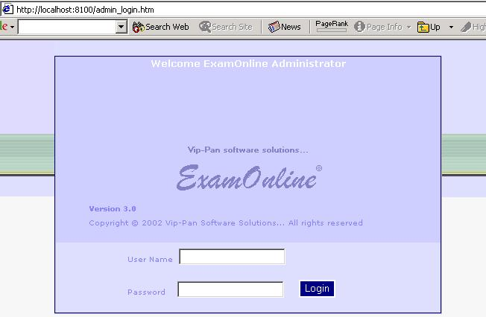

Separate control panel for each administrator to configure and manage his tests. The administrator can start, stop, delete and manage the tests. He can Add, Edit , View and Delete questions. He can also configure a new test. | 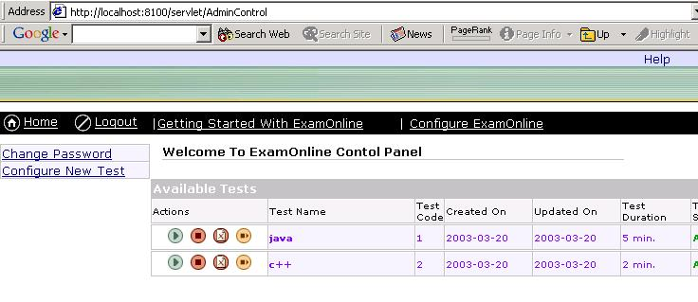
The administrator configures a new test by simply filling up the forms and then adding the desired number of questions to each and every subject. |  | 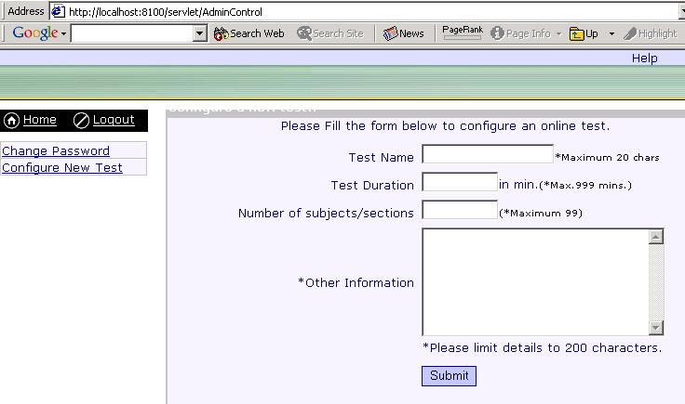

Each user has his own control panel from where he can choose the following links – My Test Center, My Score Card, Change Password and Change Account Information. | 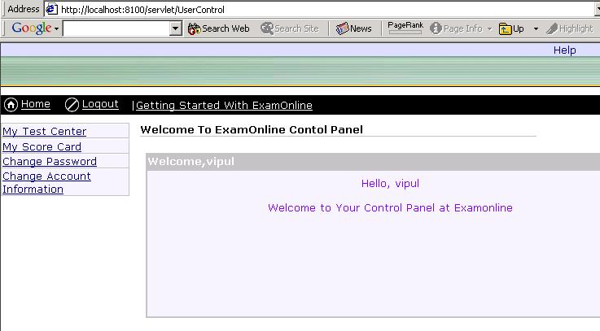

The test taker can choose from all the available tests the test he wishes to appear for from the My Test Center link. | 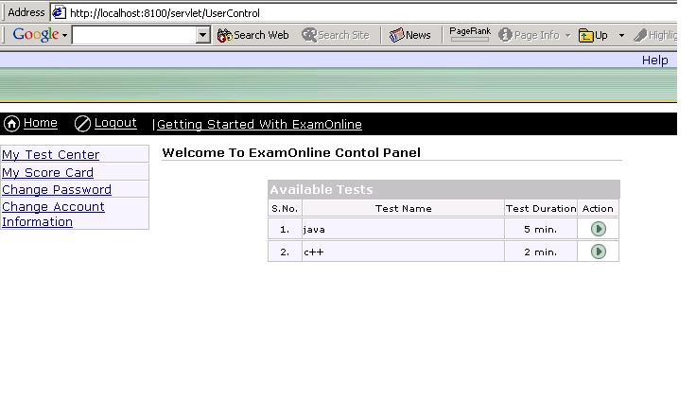

The user can rate his performance by viewing the detail result card using the My Score Card link. | 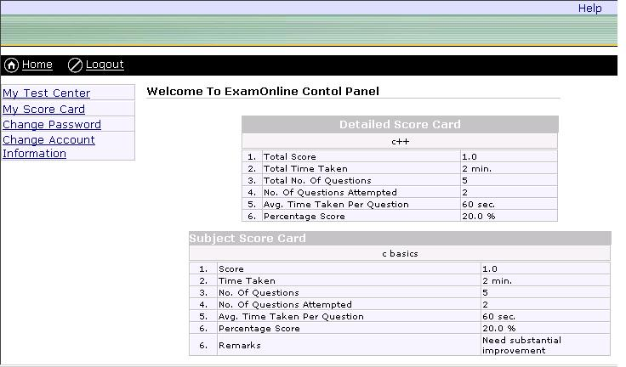

The user can change his account information using the Change Account Information link. | 